Carla Fernández González. UO244965

Dynamic Programming

# RoadCity

­­The problem is the following:

We are given a map, a starting point and an end point. We have to return the number of possible paths to go from the starting point to the ending point.

My solution for this problem involves:

1. Create a matrix of long values with the specified width and height.
2. When the user adds a barrier at a point, I specify that point as having 0 possible paths.
3. Check the different exceptional cases: the user specifies a point out of the table, starting point and end point are the same…In those cases, return -1.
4. In the general case, rows above the starting row and columns to the right of the starting column will have value 1.
5. For each point of the matrix, paths_current = paths_left + paths_bottom
6. Return the value for the end point.

Complexity:

The complexity for this solution is O (n2). I need to iterate through the whole matrix summing and changing each value.

Tables:

Case1:

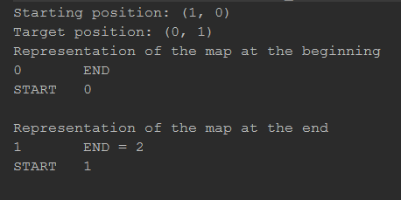

Case2:

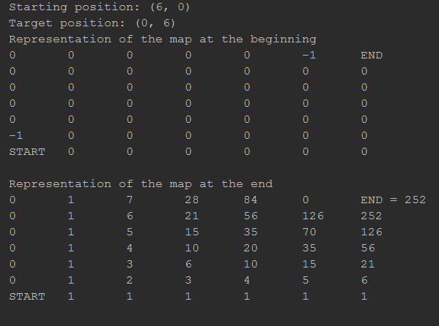

Case3:

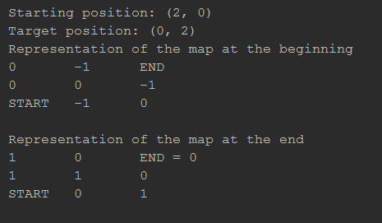

Case5:

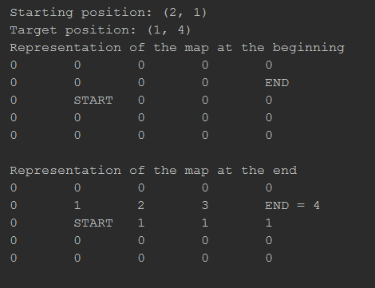

Case6:

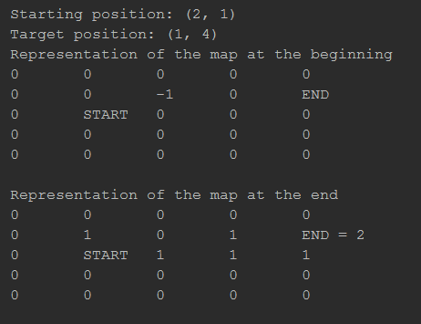

Case7:

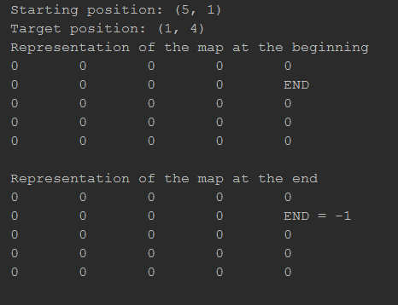

Case8:

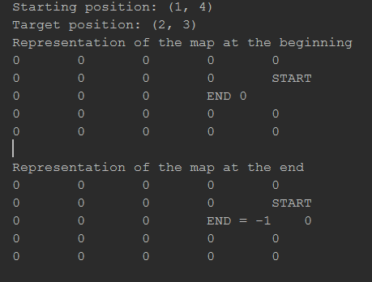

Case9:

